###### 

**PUCIT**

Punjab University College of Information Technology



**DevLearn - An eLearning Platform**

**TABLE OF CONTENTS**

1. introduction 3

1.1 project title 3

1.2 project overview statement 3

1.3 project goals & objectives 4

1.4 high-level system components 4

1.5 list of optional functional units 4

1.6 application architecture 5

1.7 gantt chart 5

1.8 hardware and software specification 6

1.9 tools and technologies used with reasoning 6

# 

## 1.1 Project Title

DevLearn - An eLearning Platform.

## Project Overview Statement.

|  |
| --- |
| **Project Title**: DevLearn - An eLearning Platform. |
| **Group Leader:** Mr. Abu Huraira |
| **Project Members:**   |  |  |  |  | | --- | --- | --- | --- | | Name | Registration # | Email Address | Signature | | Ikram Anwar | BSEF19A512 | bsef19a512@pucit.edu.pk |  | | Ahmar Farooq | BSEF19A528 | bsef19a528@pucit.edu.pk |  | | Muhammad Abdullah | BSEF19A529 | bsef19a529@pucit.edu.pk |  | | M. Subhan Ansari | BSEF19A535 | bsef19a535@pucit.edu.pk |  | | Abu Huraira | BSEF19A545 | bsef19a545@pucit.edu.pk |  | |
| **Project Goal:** The goal is to automate the learning process and to give a free source of education by developing an e-learning platform. |
| **Objectives:**   |  |  | | --- | --- | | Sr.# |  | | 1 | To provide an effective and reliable platform for learning. | | 2 | To fulfill the flaws of existing e-learning platforms. Like free-of-cost courses | | 3 | To save a lot of time and effort. | | 4 | To help the students financially by giving them a free source of education. | | 5 | It helps the students to secure jobs in the growing field of development. | | 6 |  | |
| **Project Success Criteria:** Our project will meet the success criteria if it effectively manages the process of giving them high-quality courses of programming by collaborating with professional developers. |
| **Assumptions, Risks, and Obstacles:** Secure System |
| **Organization Address** (if any): FCIT Quaid-e-Azam Campus Lahore |
| **Type of project:** Development |
| **Target End users**: Every enthusiast can learn |
| **Development Technology:** Object-Oriented |
| **Platform:** Web-based |
| **Suggested Project Supervisor:** Sir Umair Babar |
| **Approved By:** |
| **Date:** |

## 1.3 Project Goals & Objectives

The objective of this process is to develop an e-learning platform of different programming languages. This will be computerized and can be accessed online. This software will make the student capable to do their learning process online instead of visiting different departments and offices and don’t want to pay expensive dues.

## 1.4 High-level system components

These are the high-level components of the system.

* Login
* Signup
* View user Dashboard.
* Verified persons can upload courses.
* Enroll for Courses.
* Generating results.
* Our own playGround for programming
* Quizzes and assignments (playGround Based).
* QnA section (query-based).

.

## 1.5 List of optional functional units

* Forget Password scenario
* Backup Data
* Live Sessions like Google Meeting, zoom.
* Signup with other accounts like google, Facebook, etc.

## 1.6 Application Architecture

.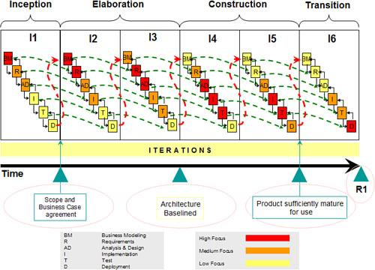

## 1.7 Gantt chart

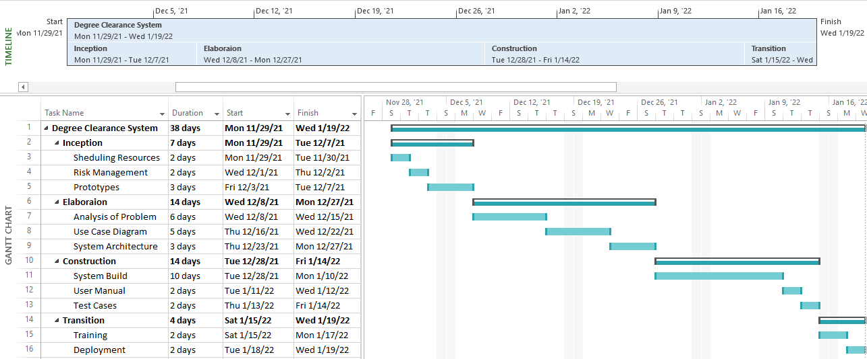

## 1.8 Hardware and Software Specification

* Intel Core™2 Duo Processor or higher
* RAM 512 or higher
* All operating systems having web browsers

## 1.9 Tools and Technologies

**Development Process:**

We will follow an iterative development process.

**Programming Languages:**

* **React and Redux**

For front-end purposes, React and redux will be used.

* **Tailwind**

For Styling purposes of the website, Tailwind will be used.

* **Express**

For Server and back-end purposes, Express will be used.

**Tools:**

* **Adobe XD and Adobe Photoshop**  
  We will use adobe photoshop for designing the layouts of our web pages.
* **VS Code**

For writing code of Web page front end and handling the back-end business logic of the system as well as managing data by collaborating with the database. VS code will be used.

* **Node Js**

We will use Node Js for creating an express server and react codes.

* **Rational Rose and Lucid Chart**

For all types of UML diagrams and visual modeling for the conceptual representation of our system, we will use Rational Rose and Lucid Chart as our tools.

* **MS Word**

Microsoft Word will be used for proper documentation as well as for making an elegant user manual of the Software System.

* **MongoDB**

This MongoDB will be used as a database for storing data of students, faculty, and applications of other business rules.

* **GitHub and SourceTree**

This will be used for uploading and pushing code to GitHub. For pushing purposes we’ll use SourceTree.